🌟 Vision Statement
Bibliotech redefines book retail by converging physical/digital experiences through real-time AI personalization, blockchain-authenticated collectibles, and augmented reality. It's a senior-engineer portfolio piece showcasing mastery of complex systems, cutting-edge integrations, and production-grade deployment.

📜 Comprehensive Scenario

User Journey
- Guest Experience
  - Browse AI-curated "Book Journeys" (themed collections)
  - Preview rare editions in AR with blockchain authenticity certificates
  - See real-time "Trending Near You" notifications
- Member Experience
  - Build "Reader DNA" profile via ML-powered taste analysis
  - Join virtual book clubs with synchronized reading progress
  - Earn NFT achievements for collecting rare editions
  - Receive dynamic discounts based on loyalty + demand
- Staff Workflow
  - AR-assisted shelf scanning for inventory audits
  - Blockchain-verified order fulfillment
  - Predictive restocking alerts
- Admin Operations
  - AI-driven pricing dashboard
  - Real-time demand heatmaps
  - Timed AR book launch events

🚀 Complete Feature Catalog

I. Discovery & Engagement
Feature | Tech Stack | Senior Challenge
Living Catalog | ML.NET, Cosmos DB | Real-time metadata evolution
AR Book Previews | React Native AR Kit, USDZ | 3D model optimization
Geolocation Trends | GeoIP, SignalR | Proximity clustering
Book DNA Profiles | ML.NET clustering | Personalized taste modeling
Sentiment Reviews | Azure Text Analytics | Emotion scoring algorithm

II. Transaction System
Feature | Tech Stack | Senior Challenge
Blockchain Certs | Hedera SDK, Web3.js | Hybrid public/private chains
Dynamic Pricing | RulesEngine.NET, Redis | Real-time demand sensing
Saga-Pattern Orders | Masstransit, RabbitMQ | Distributed rollbacks
NFT Achievements | Ethereum, OpenZeppelin | Gas optimization
AR Navigation Pickup | ARCore/ARKit, Beacons | Centimeter-accurate positioning

III. Community Ecosystem
Feature | Tech Stack | Senior Challenge
Virtual Book Clubs | WebRTC, Agora SDK | 100-user sync rooms
Reading Sync | CRDTs, Yjs | Conflict-free data sync
Time Capsule Editions | Azure Blob Storage | Content expiration policies
Holographic Events | ARKit, MediaPipe | Real-time avatar rendering

IV. Enterprise Intelligence
Feature | Tech Stack | Senior Challenge
Predictive Restocking | Python ML, gRPC | Cross-language interoperability
Demand Heatmaps | Azure Maps, Kafka | Real-time geo-analytics
AR Shelf Auditing | OpenCV.NET, ONNX | Edge-computer vision
Publisher Analytics | PowerBI Embedded | RBAC data isolation

V. Infrastructure Foundation
Feature | Tech Stack | Senior Challenge
Modular Monolith | .NET 8, DDD | Bounded context isolation
Real-Time Sync | Redis, SignalR | 10K msg/sec throughput
Offline-First Mobile | WatermelonDB | CRDT conflict resolution
Hybrid Blockchain | Ganache, Hedera | Consensus bridging

Step-by-Step Development Handbook: Next-Gen Bookstore App
Tech Stack: React Native (Frontend), .NET 8 (Backend)
Goal: Build a recruiter-impressive app with real-time features, AI, blockchain, and AR.

Phase 1: Core Infrastructure & Book Catalog
Prerequisite: Set up React Native project (Expo/CLI) and .NET 8 solution (Modular monolith with vertical slices.).

Feature: Book Catalog with Filters/Sorting
Layer | Steps
Backend | 1. Create Book entity (Title, ISBN, Price, Stock, etc.).  2. Implement EF Core BookRepository with filtering/sorting (author, genre, price).  3. Build paginated API endpoint: GET /api/books?page=1&size=20&sort=price.
Frontend | 1. Create BookListScreen with FlatList.  2. Add filter/sort UI (dropdowns, sliders).  3. Integrate API using Axios + React Query for caching.

Feature: Book Details
Layer | Steps
Backend | 1. Add BookDetails DTO with nested properties (publisher, formats).  2. Create endpoint: GET /api/books/{id}.
Frontend | 1. Build BookDetailScreen with image carousel and metadata.  2. Add "Bookmark" and "Add to Cart" buttons (stub functions).

Phase 2: User Auth & Membership

Feature: User Registration/Auth
Layer | Steps
Backend | 1. Implement ASP.NET Identity with JWT.  2. Add Member entity (loyalty points, order count).  3. Endpoints: POST /api/auth/register, /login.
Frontend | 1. Create AuthScreen (login/register forms).  2. Store tokens using react-native-encrypted-storage.  3. Add role-based routing (member/staff/admin).

Phase 3: Bookmarking & Cart

Feature: Whitelist (Bookmarks)
Layer | Steps
Backend | 1. Create Bookmark entity (MemberId, BookId).  2. Add endpoints: POST /api/bookmarks, GET /api/bookmarks.
Frontend | 1. Add bookmark icon to BookDetailScreen.  2. Build BookmarksScreen with swipe-to-delete.

Feature: Cart with Offline Support
Layer | Steps
Backend | 1. Create Cart entity and API: POST /api/cart, GET /api/cart.  2. Use Redis for temporary cart storage.
Frontend | 1. Implement cart using WatermelonDB (offline-first).  2. Sync data on app reopen.

Phase 4: Order Processing & Discounts

Feature: Order Placement
Layer | Steps
Backend | 1. Create Order aggregate (OrderItems, Status, ClaimCode).  2. Use MediatR for PlaceOrderCommand with:  - Inventory reservation  - Discount calculation (RulesEngine.NET)  - Claim code generation.
Frontend | 1. Build CheckoutScreen with order summary.  2. Integrate email sending (SendGrid API).

Feature: Stackable Discounts
Layer | Steps
Backend | 1. Implement discount rules:  - 5% for 5+ books  - 10% loyalty discount after 10 orders.  2. Use RulesEngine.NET for conflict resolution.
Frontend | 1. Display discount breakdown in cart.  2. Animate discount triggers (Lottie).

Phase 5: Real-Time Ecosystem

Feature: Live Inventory & Broadcasts
Layer | Steps
Backend | 1. Use SignalR for real-time updates.  2. Broadcast events:  - InventoryUpdated (Redis Pub/Sub)  - PurchaseMade (anonymized).
Frontend | 1. Integrate SignalR client.  2. Show toast: "User in Berlin bought Dune!".

Feature: Staff Order Processing
Layer | Steps
Backend | 1. Create StaffEndpoint to validate claim codes.  2. Use Hangfire for background order processing.
Frontend | 1. Build staff portal (React Native WebView or separate app).  2. QR scanner for claim codes.

Phase 6: AI & Personalization

Feature: Recommendation Engine
Layer | Steps
Backend | 1. Train ML.NET model:  - Collaborative filtering (user purchases)  - Content-based (book descriptions).  2. Deploy as Azure Function.
Frontend | 1. Add "Recommended For You" section.  2. Implement skeleton loaders.

Feature: Dynamic Pricing
Layer | Steps
Backend | 1. Create pricing service using:  - Inventory age  - Demand trends.  2. Expose API: GET /api/books/{id}/dynamic-price.
Frontend | 1. Highlight dynamic prices with flash animation.

Phase 7: Blockchain & AR Integration

Feature: Blockchain Order Verification
Layer | Steps
Backend | 1. Use Hedera Hashgraph SDK to store order hashes.  2. Add BlockchainService to generate explorer links.
Frontend | 1. Show "Verified on Blockchain" badge in order history.  2. Link to Hedera explorer.

Feature: AR Book Previews
Layer | Steps
Backend | 1. Create ARPreview endpoint (returns 3D model/book metadata by ISBN).
Frontend | 1. Integrate React Native AR Kit.  2. Build AR scanner for book blurbs/ratings.

Phase 8: Admin & Analytics

Feature: Admin Dashboard
Layer | Steps
Backend | 1. Implement CRUD for books with EF Core.  2. Add timed discounts/announcements (Quartz.NET scheduler).
Frontend | 1. Build admin panel (React Native + Recharts).  2. Real-time inventory heatmaps.

Feature: Predictive Restocking
Layer | Steps
Backend | 1. Use ML.NET to forecast demand.  2. Trigger Azure Logic Apps for supplier emails.
Frontend | 1. Show restock alerts in admin panel.

Phase 9: DevOps & Testing

Infrastructure
Step | Action
Backend | 1. Containerize with Docker.  2. Deploy to AKS using Terraform.  3. Set up OpenTelemetry + Prometheus.
Frontend | 1. Configure EAS for Expo builds.  2. Use Detox for E2E tests.

Testing
Layer | Tools
Backend | xUnit (unit tests), Locust (load tests), Postman (API tests).
Frontend | Jest (unit), React Native Testing Library (integration), Detox (E2E).

Phase 10: Polish & Deployment
- UI/UX Enhancements:
  - Add Lottie animations for cart interactions.
  - Implement dynamic theming (dark mode + publisher skins).
- Performance:
  - Optimize images with react-native-fast-image.
  - Use React Query for efficient data fetching.
- Deployment:
  - Backend: Azure Kubernetes Service (AKS) with Istio.
  - Frontend: App Store/Play Store via EAS.
- Recruiter Touches:
  - Add "Architecture Overview" screen in app (show tech stack).
  - Include load-test results in documentation (10K users simulated).

Development Order Dependencies
- Start With: Phase 1 → Phase 2 → Phase 3 (core user flow).
- Parallel Build:
  - Phase 4 (Orders) + Phase 5 (Real-Time)
  - Phase 6 (AI) + Phase 8 (Admin)
- Advanced Features Last: Phase 7 (Blockchain/AR) after core is stable.
- Testing: Write tests alongside features (e.g., build xUnit tests while coding BE).
⚠️ Critical Path: Complete Phase 4 (Discounts) before Phase 7 (Blockchain), as blockchain relies on finalized order data.

Design System Foundation
- Color Palette:
  - Primary: #4F46E5 (Deep Indigo)
  - Secondary: #10B981 (Vibrant Emerald)
  - Accent: #F59E0B (Amber Gold)
  - Background: #F9FAFB (Cream White)
  - Text: #1F2937 (Charcoal Black)
  - Error: #EF4444 (Crimson Red)
- Typography:
  - Headings: Montserrat-Bold (24-32px)
  - Body: Inter-Regular (16px)
  - Microcopy: Inter-Light (12px)
  - Special: CormorantGaramond-Italic (Book blurbs)
- Icons:
  - Library: MaterialCommunityIcons
  - Custom: SVG illustrations for empty states
- Motion Principles:
  - Entrance: Slide-up (30% opacity → 100% in 400ms)
  - Transitions: Shared element transitions between cards/details
  - Feedback: Haptic vibration + Lottie micro-animations

Phase 1: Core Infrastructure & Book Catalog

Book List Screen
Element | Specification
Layout | Masonry grid (2 columns) with 8px spacing
Card Design | - White card with 12px rounded corners  - Cover image (3:4 aspect) with gradient overlay  - Floating bookmark icon (top-right)
Text Hierarchy | 1. Title (Montserrat-Bold 16px #1F2937)  2. Author (Inter-Regular 12px #6B7280)  3. Price (Montserrat-Bold 18px #4F46E5)
Loading | Skeleton loader: Animated gradient over placeholder rectangles
Empty State | Custom SVG + "No books found" in CormorantGaramond-Italic
Pull-to-Refresh | Amber Gold progress indicator + book flipping animation

Filter/Sort Panel
Element | Specification
Trigger | Floating Action Button (FAB) with filter icon
Animation | Bottom sheet slide-up (40% screen height)
Controls | - Range slider with emerald track  - Chip-based multi-select (genre/format)  - Toggle switches for availability
Microinteractions | Chip select: Scale 0.9 → 1.1 with haptic

Book Detail Screen
Element | Specification
Hero Section | - Parallax cover image (full-width)  - Back button (top-left) with shared transition
Metadata | - Title (Montserrat-Bold 28px)  - "Scrolling marquee" for authors  - Rating stars with pulse animation
Action Bar | - Bookmark (heart icon with fill animation)  - Add to Cart (floating bar with bounce)
Description | Expandable text with "Read More" gradient fade
404 State | Glitch art animation + "This book vanished!"

Phase 2: User Auth & Membership

Auth Screen
Element | Specification
Layout | Centered card (80% width) with soft drop shadow
Input Fields | - Floating labels  - Underline animation on focus (indigo → emerald)  - Password visibility toggle with eye icon morph
Social Login | OAuth buttons with brand-color wave effects
Error States | Input shake + crimson underline pulse
Success Flow | Confetti Lottie + "Welcome to Bibliotech!" message

Role-Based Navigation
User Type | Visual Indicator
Member | Indigo bottom tab bar with subtle glow
Staff | Amber Gold app bar with QR icon
Admin | Deep Purple gradient header

Phase 3: Bookmarking & Cart

Bookmarks Screen
Element | Specification
Layout | List view with "cover flow" tilt effect
Empty State | Animated bookshelf SVG + "Your literary treasures await"
Swipe Actions | - Delete: Crimson trash can reveal  - Share: Emerald arrow slide
Microinteraction | Bookmark fill: Liquid animation from bottom-up

Cart Screen
Element | Specification
Offline Badge | Pulsating amber "Disconnected" indicator
Item Card | - Swipe-to-delete with friction physics  - Quantity stepper with "+/-" bounce
Summary Panel | Sticky bottom bar with emerald "Checkout" CTA
Sync Animation | Data wave when reconnecting

Phase 4: Order Processing & Discounts

Checkout Flow
Step | UI/UX Details
1. Summary | - Discount breakdown with emerald highlight  - Progress stepper (3 steps)
2. Pickup | Store locator map with pulsating pins
3. Confirmation | - Claim code as "cracked glass" effect  - Email animation (paper airplane trajectory)

Discount Animation
- Trigger: When rules met (e.g., 5+ books)
- Effect: Golden coins raining → transforming into % badge
- Sound: Subtle "cha-ching" SFX (toggleable)

Phase 5: Real-Time Ecosystem

Live Purchase Broadcast
Element | Specification
Toast Notification | Slide-down card with:  - Location pin (pulsating)  - Book cover (scaling in)  - Text: "Someone in [City] just bought [Title]!"
Animation | Book flying from location pin to "Library" icon

Staff Processing Portal
Element | Specification
QR Scanner | - Fullscreen camera  - Animated targeting reticle  - Haptic pulse on successful scan
Order Validation | Blockchain verification badge (rotating seal)

Phase 6: AI & Personalization

Recommendation Engine
Element | Specification
UI Container | "DNA helix" themed carousel
Loading State | Books assembling like puzzle pieces
Empty State | Robot reading book SVG
Interaction | Swipe with page curl effect

Dynamic Pricing
State | Visual Treatment
Price Drop | Emerald downward arrow + "trending down" graph
Premium Pricing | Amber Gold crown badge + "Collector's Item" tag

Phase 7: Blockchain & AR Integration

Blockchain Verification
Element | Specification
Visual Design | Holographic badge with light refraction
Animation | Hexagonal particles assembling into lock icon
Details View | Animated transaction flowchart

AR Book Preview
Element | Specification
Scanning UI | - Pulsating radar overlay  - Depth-aware focus ring
3D Model | - Physically-based rendering (PBR) materials  - Page flip animation on tap
Info Card | Semi-transparent panel with parallax effect

Phase 8: Admin & Analytics

Dashboard
Element | Specification
Data Viz | - Animated heatmaps (geolocation)  - Real-time sales funnel
CRUD Interface | Drag-and-drop book management
Timed Discounts | Visual timeline with draggable markers

Predictive Restocking
Element | Specification
Alert System | Pulsating low-stock indicator
Forecast Graph | Animated projection curve
Automation Flow | Visual pipeline showing supplier → warehouse

Phase 9: Polish & Deployment

Advanced Animations
- Cart Interaction:
  - Add to cart: Book flies from detail screen → cart icon
  - Empty cart: Books disintegrate into particles
- Theme Transition:
  - Dark mode toggle: Smooth color morphing
  - Publisher skins: Gradient overlay transition

Performance Optimizations
Technique | Implementation
Image Handling | - Placeholders: BlurHash  - Loading: IntersectionObserver + fade
Navigation | Shared element transitions between screens
Data Fetching | Skeleton screens with shimmer animation

Error States
Scenario | UI Treatment
No Connection | Glowing amber "disconnected" icon + retry button
Page Missing | 404: Book vanishing into black hole animation
System Failure | "Library on fire" SVG with ember particles

Phase 10: Final UI Toolkit

Component Library
- Buttons:
  - Primary: Indigo gradient with soft shadow
  - Secondary: White with indigo border (border-radius: 24px)
  - Icon: Circular with pulsate animation
- Cards:
  - Depth: 3-layer neumorphic design
  - Hover: Elevation + shadow direction change
- Navigation:
  - Bottom Tabs: Liquid swipe indicator
  - Gestures: Edge swipe for back navigation

Microinteraction Catalog
Trigger | Feedback
Tap | Scale 0.95 + haptic pulse
Long Press | Concentric circles + vibration
Swipe | Content parallax + resistance physics
Scroll | Dynamic header transformation

Motion Design System
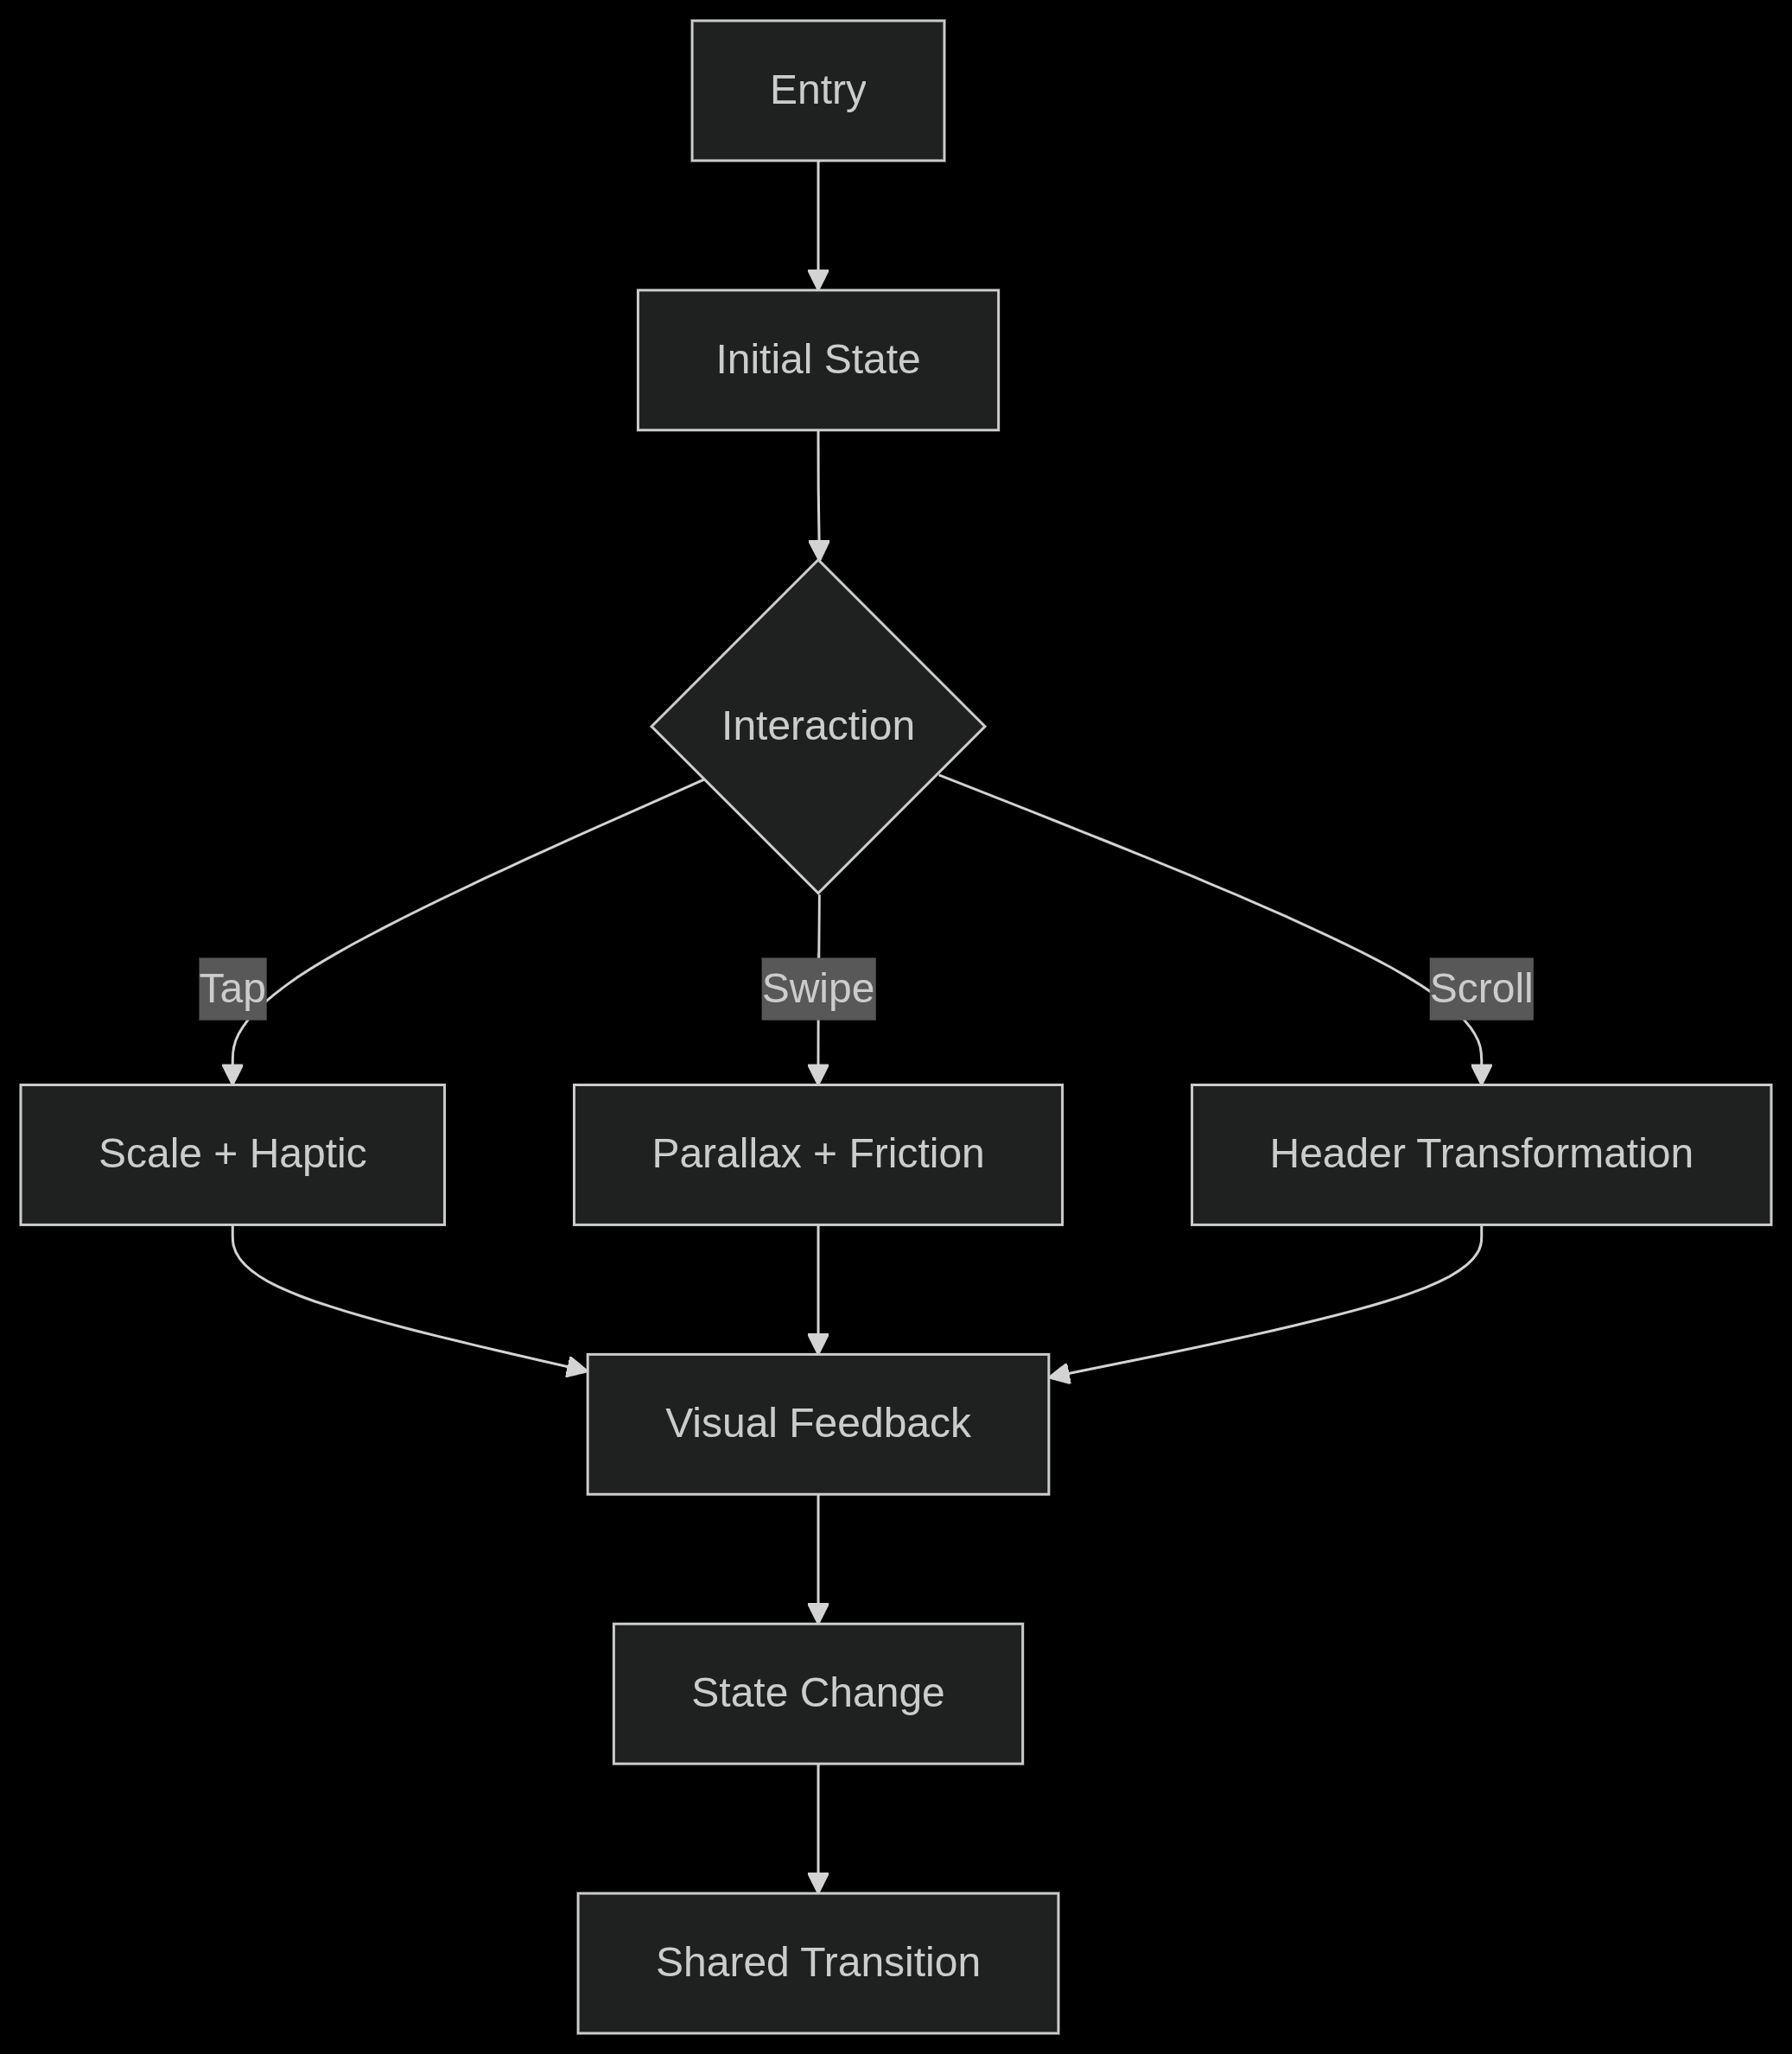
Accessibility Features
- Color Modes:
  - High contrast theme for visually impaired
  - Dyslexia-friendly font toggle
- Motion Control:
  - Reduce motion toggle
  - Animation speed slider
- Audio Cues:
  - Spatial audio for navigation
  - Distinct SFX for critical actions

